**TASK - 10**

**Attribute Routing with constraints with errors:**

**min constraint:**

The id should be minimum of 10 else it will show the error.

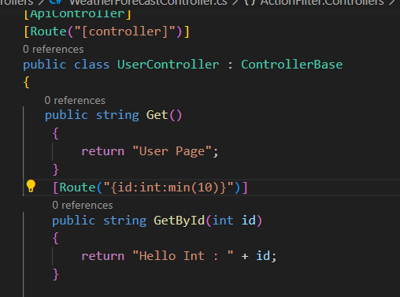

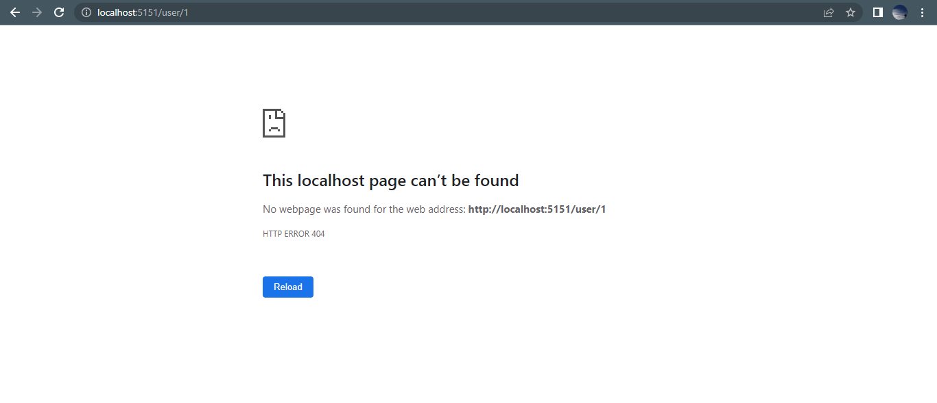

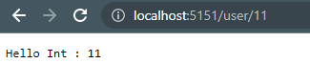

**max constraint:**

The minimum value should be 10 and the maximum value should be less than 20 else the second method gets executed.

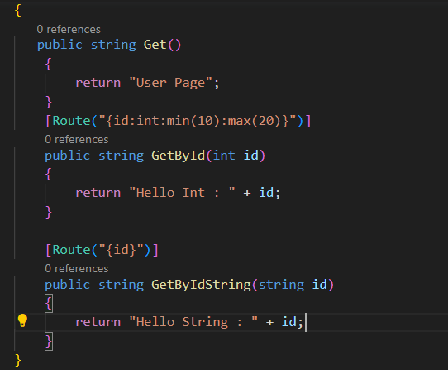

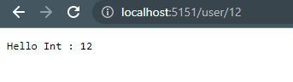

**range constraint:**

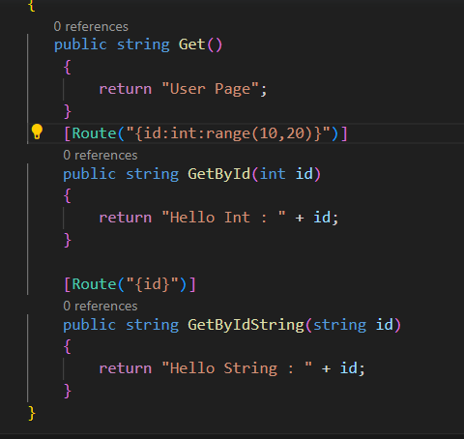

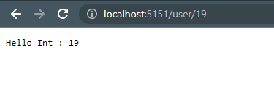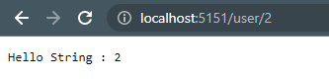

**minlength constraint:**

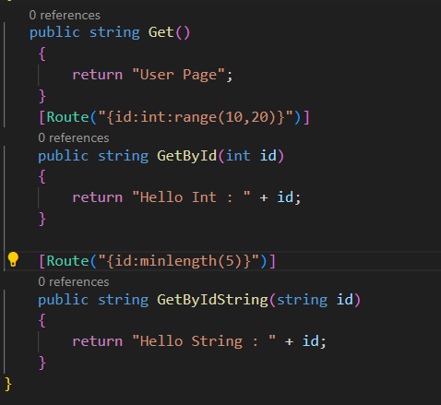

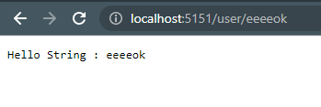

There are only 4 characters in the string. Hence the error page is displayed.

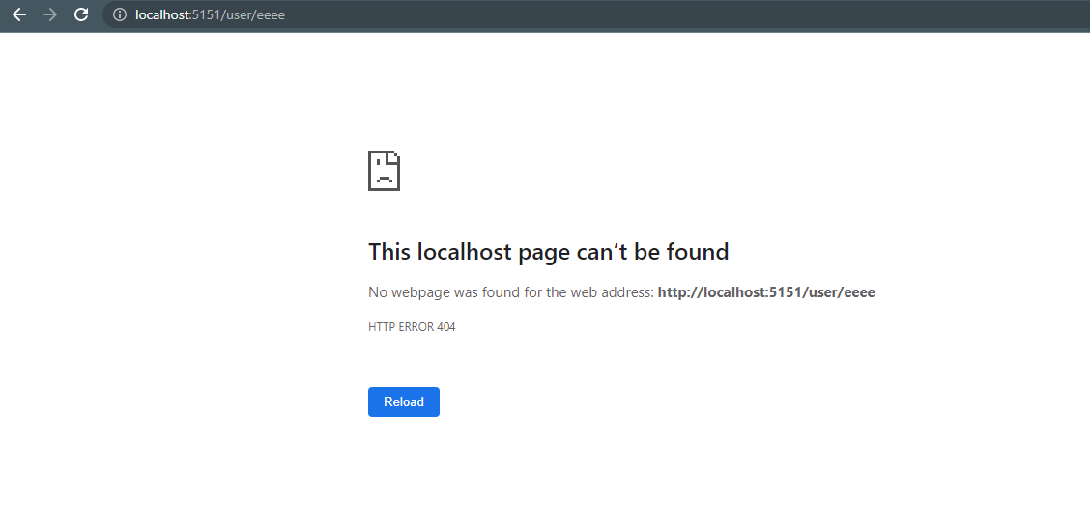

**maxlength constraint:**

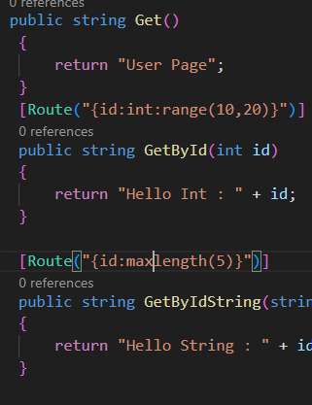

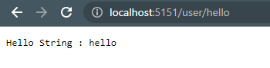

**length constraint:**

Length should be exactly of 5 characters else error page is displayed.

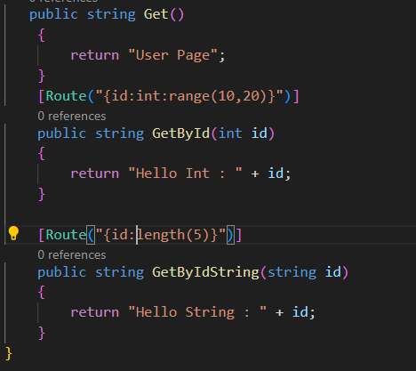

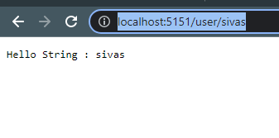

Only 4 characters. So the error page is displayed.

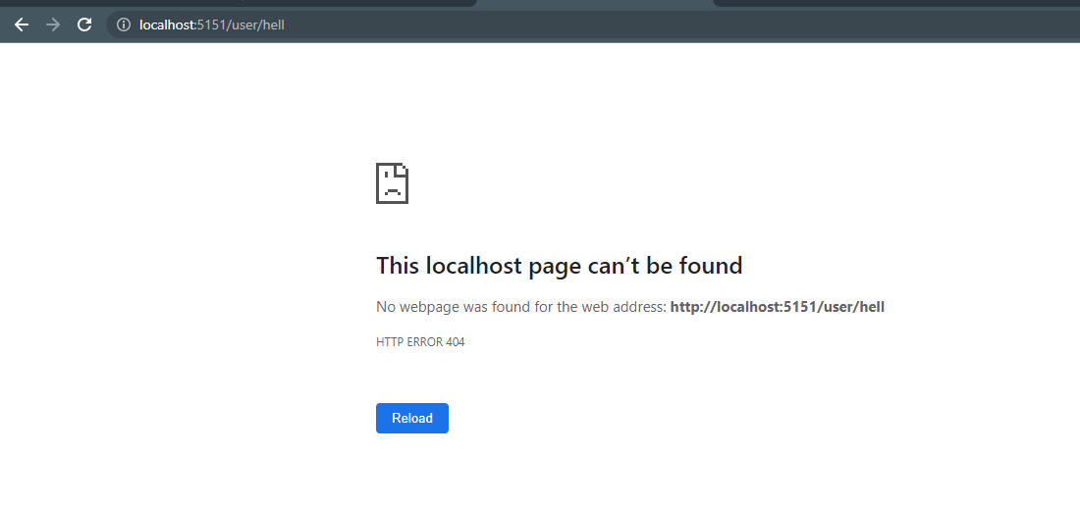

**alpha constraint:**

Only alphabets are allowed.

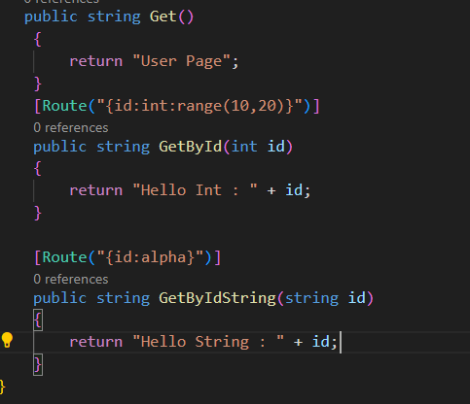

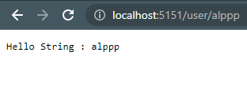

No alphabets so the other method is executed.

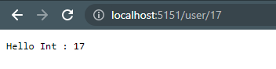

If it is alphanumeric, error page occurs.

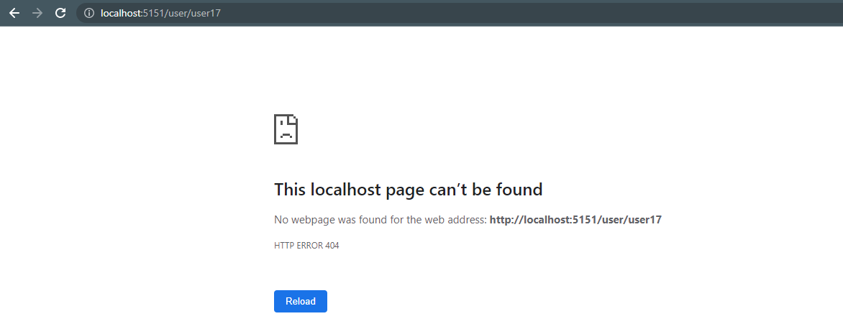

**regex constraint:**

